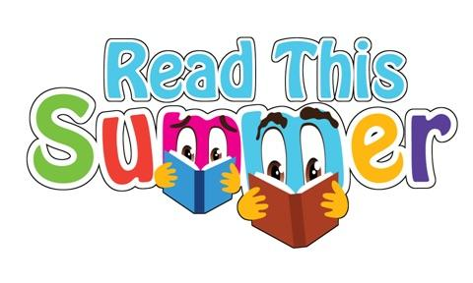
TIMOTHY HOUSE
THE DWIGHT SCHOOL
SUMMER READING 2017

Third Grade into Fourth Grade

Reading over the summer reinforces reading skills and encourages children to become lifelong learners.

Please assist your child with his/her summer reading and note the Summer Reading Activities listed below.

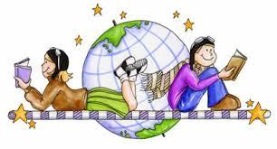

Dear Student:

We are so excited to see you next school year! We are going to have so much fun in the fourth grade! We hope you read many books, magazines, and newspapers during your break. We have attached a list of suggestions of books to read over the summer. Please read at least THREE books from the list below. However, if you find another book you really love, go ahead and read it! We hope you devour books this summer, so feel free to choose one that is not on the list. It is a good idea to go to the library or bookstores to decide which books are “just right” for you.

We have listed the books, their authors, and a brief summary to help you make your choices. Again, feel free to read as many as you would like! We have included a reading log so you can keep track of all the great reading you do this summer.

Of the three books you read, please choose two activities listed below.

Summer Book Assignment (2 Parts):
Choose two of the books you have read, and show your understanding. Below are some suggestions. Feel free to use your creativity, and do something fun!

Choose TWO books you’ve read this summer and…
• Draw a map of the setting.
• Write a short story about what the character(s) would be doing one year later.
• Imagine you could interview the protagonist. What three questions would you ask?
• Redesign the cover.
• Write a letter to the author or illustrator.
• Write a short book review. Remember to include a few sentences describing the book as well as a few sentences about why you liked it—or didn’t.

Take it to the next level…
- Choose two people or characters from two different books who you think would be great friends. Why?
- Choose one book location or setting to live in for a week—it can be fiction or nonfiction. Which book would you choose and why?
- Create a photo collage or animated trailer. (iMovie or Pic Collage are great apps for this activity)
- Recommend a book to a friend or family member. Which title did you choose and why did you recommend it?

We can’t wait for school to start and for all the exciting things we have planned for you.

Happy Reading!

Recommended Reading:

FICTION:

Fantasy:

Escape from Mr. Lemoncello’s Library by Chris Grabenstein

Kyle Keeley is the class clown and a huge fan of all games—board games, word games, and particularly video games. His hero, Luigi Lemoncello, the most notorious and creative game maker in the world, just so happens to be the genius behind the construction of the new town library. Lucky Kyle wins a coveted spot as one of twelve kids invited for an overnight sleepover in the library, hosted by Mr. Lemoncello and riddled with lots and lots of games. But when morning comes, the doors stay locked. Kyle and the other kids must solve every clue and figure out every secret puzzle to find the hidden escape route!

The One and Only Ivan by Katherine Applegate
Winner of the Newbery Medal and a #1 New York Times bestseller!
Having spent 27 years behind the glass walls of his enclosure in a shopping mall, Ivan has grown accustomed to humans watching him. He hardly ever thinks about his life in the jungle. Instead, Ivan occupies himself with television, his friends Stella and Bob, and painting. But when he meets Ruby, a baby elephant taken from the wild, he is forced to see their home, and his art, through new eyes.

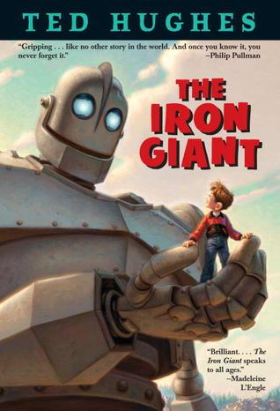
The Iron Giant by Ted Hughes
A mysterious creature stalks the land, eating barbed wire and devouring tractors and plows. The farmers are mystified—and terrified. And then they glimpse him in the night: the Iron Giant, taller than a house, with glowing headlight eyes and an insatiable taste for metal. The hungry giant must be stopped at any cost. Only a young boy named Hogarth is brave enough to lead the Iron Giant to a safe home. And only Hogarth knows where to turn when a space-bat as big as Australia, hungry for every living thing on Earth, darkens the sky.

The Wishing Spell (The Land of Stories, #1) by Chris Colfer

Alex and Conner Bailey's world is about to change, in this fast-paced adventure that uniquely combines our modern day world with the enchanting realm of classic fairy tales. The Land of Stories tells the tale of twins Alex and Conner. Through the mysterious powers of a cherished book of stories, they leave their world behind and find themselves in a foreign land full of wonder and magic where they come face-to-face with the fairy tale characters they grew up reading about. But after a series of encounters with witches, wolves, goblins, and trolls alike, getting back home is going to be harder than they thought.

Charlotte’s Web by E.B. White
Some Pig. Humble. Radiant. These are the words in Charlotte's Web, high up in Zuckerman's barn. Charlotte's spiderweb tells of her feelings for a little pig named Wilbur, who simply wants a friend. They also express the love of a girl named Fern, who saved Wilbur's life when he was born the runt of his litter.

Realistic:

Because of Mr. Terupt by Rob Buyea

Features seven narrators, each with a unique story, and each with a different perspective on what makes their teacher so special.

It’s the start of fifth grade for seven kids at Snow Hill School. There’s . . . Jessica, the new girl, smart and perceptive, who’s having a hard time fitting in; Alexia, a bully, your friend one second, your enemy the next; Peter, class prankster and troublemaker; Luke, the brain; Danielle, who never stands up for herself; shy Anna, whose home situation makes her an outcast; and Jeffrey, who hates school.

Only Mr. Terupt, their new and energetic teacher, seems to know how to deal with them all. He makes the classroom a fun place, even if he doesn’t let them get away with much . . . until the snowy winter day when an accident changes everything—and everyone.

Fish in a Tree by Lynda Mullaly Hung

Ally has been smart enough to fool a lot of smart people. Every time she lands in a new school, she is able to hide her inability to read by creating clever yet disruptive distractions. She is afraid to ask for help; after all, how can you cure dumb? However, her newest teacher Mr. Daniels sees the bright, creative kid underneath the trouble maker. With his help, Ally learns not to be so hard on herself and that dyslexia is nothing to be ashamed of. As her confidence grows, Ally feels free to be herself and the world starts opening up with possibilities. She discovers that there’s a lot more to her—and to everyone—than a label, and that great minds don’t always think alike.

All Four Stars by Tara Dairman

Meet Gladys Gatsby: New York’s toughest restaurant critic. (Just don’t tell anyone that she’s in sixth grade.) Gladys Gatsby has been cooking gourmet dishes since the age of seven, only her fast-food-loving parents have no idea! Now she’s eleven, and after a crème brûlée accident (just a small fire), Gladys is cut off from the kitchen (and her allowance). She’s devastated but soon finds just the right opportunity to pay her parents back when she’s mistakenly contacted to write a restaurant review for one of the largest newspapers in the world. But in order to meet her deadline and keep her dream job, Gladys must cook her way into the heart of her sixth-grade archenemy and sneak into New York City—all while keeping her identity a secret! Easy as pie, right?

Because of Winn-Dixie by Kate DiCamillo

The summer Opal and her father, the preacher, move to Naomi, Florida, Opal goes into the Winn-Dixie supermarket--and comes out with a dog. A big, ugly, suffering dog with a sterling sense of humor. A dog she dubs Winn-Dixie. Because of Winn-Dixie, the preacher tells Opal ten things about her absent mother, one for each year Opal has been alive. Winn-Dixie is better at making friends than anyone Opal has ever known, and together they meet the local librarian, Miss Franny Block, who once fought off a bear with a copy of WAR AND PEACE. They meet Gloria Dump, who is nearly blind but sees with her heart, and Otis, an ex-con who sets the animals in his pet shop loose after hours, then lulls them with his guitar. Opal spends all that sweet summer collecting stories about her new friends and thinking about her mother. But because of Winn-Dixie or perhaps because she has grown, Opal learns to let go, just a little, and that friendship—and forgiveness—can sneak up on you like a sudden summer storm.

Best Man by Richard Peck

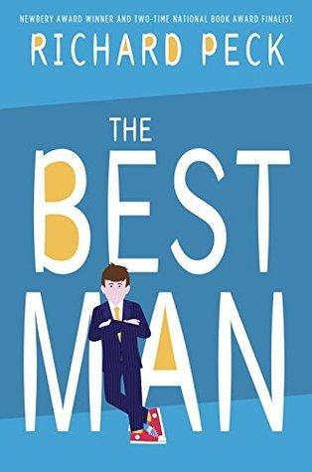
When Archer is in sixth grade, his beloved uncle Paul marries another man—Archer’s favorite student teacher. But that’s getting ahead of the story, and a wonderful story it is. In Archer’s sweetly naïve but observant voice, his life through elementary school is recounted: the outspoken, ever-loyal friends he makes, the teachers who blunder or inspire, and the family members who serve as his role models. From one exhilarating, unexpected episode to another, Archer’s story rolls along as he puzzles over the people in his life and the kind of person he wants to become…and manages to help his uncle become his best self as well.

Me and Marvin Gardens by Amy Sarig King

Obe Devlin has problems. His family's farmland has been taken over by developers. His best friend Tommy abandoned him for the development kids. And he keeps getting nosebleeds, because of that thing he doesn't like to talk about. So Obe hangs out at the creek by his house, in the last wild patch left, picking up litter and looking for animal tracks. One day, he sees a creature that looks kind of like a large dog, or maybe a small boar. And as he watches it, he realizes it eats plastic. Only plastic. Water bottles, shopping bags... No one has ever seen a creature like this before, because there's never been a creature like this before. The animal-Marvin Gardens-soon becomes Obe's best friend and biggest secret. But to keep him safe from the developers and Tommy and his friends, Obe must make a decision that might change everything

Crenshaw by Katherine Applegate
Jackson and his family have fallen on hard times. There's no more money for rent. And not much for food, either. His parents, his little sister, and their dog may have to live in their minivan. Again. Crenshaw is a cat. He's large, he's outspoken, and he's imaginary. He has come back into Jackson's life to help him. But is an imaginary friend enough to save this family from losing everything? Beloved author Katherine Applegate proves in unexpected ways that friends matter, whether real or imaginary.

The Tapper Twins Go To War (With Each Other) by Geoff Rodkey

This bestselling first book in the Tapper Twins series is a hilariously authentic showcase of what it's like to be in middle school in our digitally-saturated world, told as a colorful "oral history" with photos, screenshots, text messages, chat logs, and online gaming digital art.

Twelve-year-old twins, Claudia and Reese, who couldn't be more different...except in their determination to come out on top in a vicious prank war. But when the competition escalates into an all-out battle that's fought from the cafeteria of their New York City private school all the way to the fictional universe of an online video game, the twins have to decide if their efforts to destroy each other are worth the price. In a starred review, Publishers Weekly declared "This uproarious series opener... is packed with both laugh-out-loud moments and heart."

The Butterfly Lion by Michael Morpurgo

A lyrical and moving tale of a young boy growing up in Africa, and his lifelong friendship with a white lion.Bertie rescues an orphaned white lion cub from the African veld. They are inseparable until Bertie is sent to boarding school far away in England and the lion is sold to a circus. Bertie swears that one day they will see one another again, but it is the butterfly lion which ensures that their friendship will never be forgotten.

Graphic Novels:

Ghosts by Raina Telgemeier

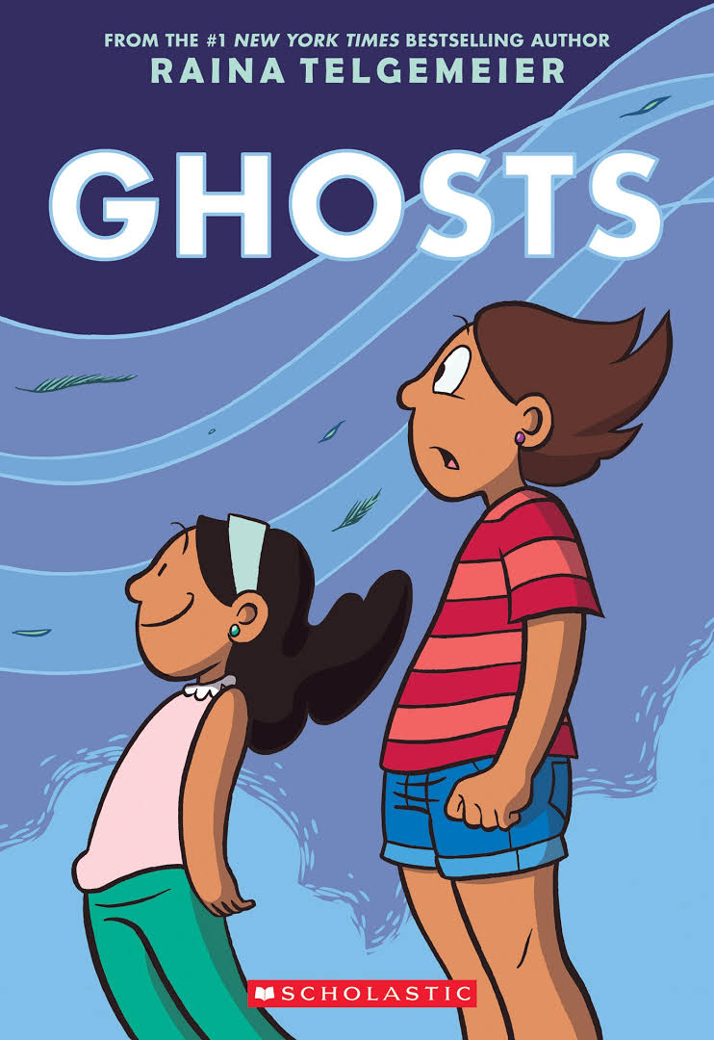 Catrina and her family are moving to the coast of Northern California because her little sister, Maya, is sick. Cat isn't happy about leaving her friends for Bahía de la Luna, but Maya has cystic fibrosis and will benefit from the cool, salty air that blows in from the sea. As the girls explore their new home, a neighbor lets them in on a secret: There are ghosts in Bahía de la Luna. Maya is determined to meet one, but Cat wants nothing to do with them. As the time of year when ghosts reunite with their loved ones approaches, Cat must figure out how to put aside her fears for her sister's sake - and her own.

El Deafo by Cece Bell

A 2015 Newbery Honor Book Going to school and making new friends can be tough. But going to school and making new friends while wearing a bulky hearing aid strapped to your chest? That requires superpowers! In this funny, poignant graphic novel memoir, author/illustrator Cece Bell chronicles her hearing loss at a young age and her subsequent experiences with the Phonic Ear, a very powerful—and very awkward—hearing aid. The Phonic Ear gives Cece the ability to hear—sometimes things she shouldn’t—but also isolates her from her classmates. She really just wants to fit in and find a true friend, someone who appreciates her as she is. After some trouble, she is finally able to harness the power of the Phonic Ear and become “El Deafo, Listener for All.” And more importantly, declare a place for herself in the world and find the friend she’s longed for.

Roller Girl by Victoria Jamieson
For most of her twelve years, Astrid has done everything with her best friend Nicole. But after Astrid falls in love with roller derby and signs up for derby camp, Nicole decides to go to dance camp instead. And so begins the most difficult summer of Astrid's life as she struggles to keep up with the older girls at camp, hang on to the friend she feels slipping away, and cautiously embark on a new friendship. As the end of summer nears and her first roller derby bout (and junior high!) draws closer, Astrid realizes that maybe she is strong enough to handle the bout, a lost friendship, and middle school… in short, strong enough to be a roller girl.

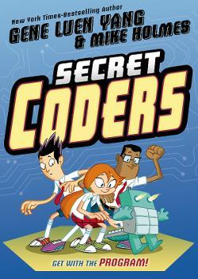
Secret Coders by Gene Luen Yang

Hopper is not excited to start a new school, which looks more like a haunted house. Her classes are boring, she runs afoul of her teachers, and, worst of all, no one wants to sit with her at lunch. Her only company is a weird bird who opens a third eyeball. What could be going on? Hopper’s classmate Eni thinks he knows: the birds are robots, and they’re responding to numbers in binary. From there, Eni and Hopper discover all kinds of coding-based tricks around school. They figure out a lock combination, discover a robot, pull a prank on their classmates, and, thrillingly, find a hidden passageway. Now they’re not only playing around with programming but investigating a mystery!

Historical Fiction:

War Horse by Michael Morpurgo
In 1914, Joey, a beautiful bay-red foal with a distinctive cross on his nose, is sold to the army and thrust into the midst of the war on the Western Front. With his officer, he charges toward the enemy, witnessing the horror of the battles in France. But even in the desolation of the trenches, Joey's courage touches the soldiers around him and he is able to find warmth and hope. But his heart aches for Albert, the farmer's son he left behind. Will he ever see his true master again?

I Survived Series by Lauren Tarshis

Each book in the series tells a terrifying and thrilling story from history, through the eyes of a boy who lived to tell the tale.

Paper Wishes by Lois Sepahban

Ten-year-old Manami did not realize how peaceful her family's life on Bainbridge Island was until the day it all changed. It's 1942, after the attack on Pearl Harbor, and Manami and her family are Japanese American, which means that the government says they must leave their home by the sea and join other Japanese Americans at a prison camp in the desert. Manami is sad to go, but even worse is that they are going to have to give her dog, Yujiin, to a neighbor to take care of. Manami decides to sneak Yujiin under her coat, but she is caught and forced to abandon him. She is devastated but clings to the hope that somehow Yujiin will find his way to the camp and make her family whole again. It isn't until she finds a way to let go of her guilt that Manami can accept all that has happened to her family.

Nonfiction:

Ada’s violin: the story of the Recycled Orchestra of Paraguay by Susan Hood

Ada Ríos grew up in Cateura, a small town in Paraguay built on a landfill. She dreamed of playing the violin, but with little money for anything but the bare essentials, it was never an option...until a music teacher named Favio Chávez arrived. He wanted to give the children of Cateura something special, so he made them instruments out of materials found in the trash. It was a crazy idea, but one that would leave Ada—and her town—forever changed. Now, the Recycled Orchestra plays venues around the world, spreading their message of hope and innovation.

Aaron and Alexander: the most famous duel in American history by Dan Brown

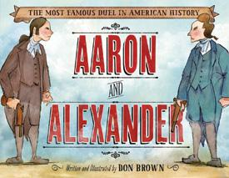
Aaron Burr and Alexander Hamilton were both fierce patriots during the Revolutionary War, but the politics of the young United States of America put them in constant conflict. Their extraordinary story of bitter fighting and resentment culminates in their famous duel. For young patriots who may not yet know the shocking and tragic story, Aaron and Alexander captures the spirit of these two great men who so valiantly served their country and ultimately allowed their pride and ego to cause their demise

Echo Echo: reverse poems about Greek myths by Marilyn Singer

What happens when you hold up a mirror to poems about Greek myths? You get a brand-new perspective on the classics! And that is just what happens in Echo Echo. Read one way, each poem tells the story of a familiar myth; but when read in reverse, the poems reveal a new point of view! Well-known legends, including the stories of Pandora's box, King Midas and his golden touch, Perseus and Medusa, Pygmalion, Icarus and Daedalus, Demeter and Persephone, and Echo and Narcissus are part of this poetry collection.

Mummy Makers of Egypt by Tamara Bower

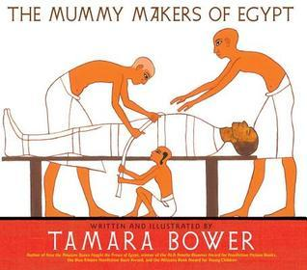
Artifacts, funerary customs, kid-loving gory details of the mummification process, hieroglyphs, and details of life in ancient Egypt are told through the eyes of Ipy, whose father is embalmer to the King. Yuya, father of the Queen, has died and Ipy must help his father in the mummification process. Yuya is an actual mummy and the discovery of his tomb is an entertaining story in itself, with the archaeologist Theodore Davis fainting at the sight of so much gold, and the portly Gaston Maspero getting stuck while trying to climb into the tomb. Yuya's tomb was a spectacular discovery in the Valley of the Kings that was later overshadowed only by the discovery of King Tut, Yuya's great-grandson. The book features sidebars of hieroglyphs and their meanings, a map, and an afterword telling more about the life of Yuya, of the burial process, and ancient Egypt in general.

Under Water, Under Earth by Alexandra & Daniel Mizielinska

Prepare to traverse subterranean soil and sink to watery depths in this richly informative, oversize double-ended picture book. Divided in two, this encyclopedic volume explores underground curiosities in one half and underwater marvels in the other and converges at the deepest points of both: the Earth’s core and Challenger Deep, the nethermost region of the Mariana Trench. While paneled diagrams break down more elusive processes (such as the evolution of a sinkhole), crisp cross-sections of electrical wiring or mineshaft mechanics illustrate the human consumption of natural resources.

ADDITIONAL RESOURCES:

- Books can be purchased at:

- Bank Street College Book Store
2780 Broadway (between 107th and 108th Street)

- Book Culture on Columbus
450 Columbus Avenue (between 81st and 82nd Street)

- Barnes & Noble Bookstore
Most Locations

- Books can be borrowed from the New York Public Library (www.nypl.org)

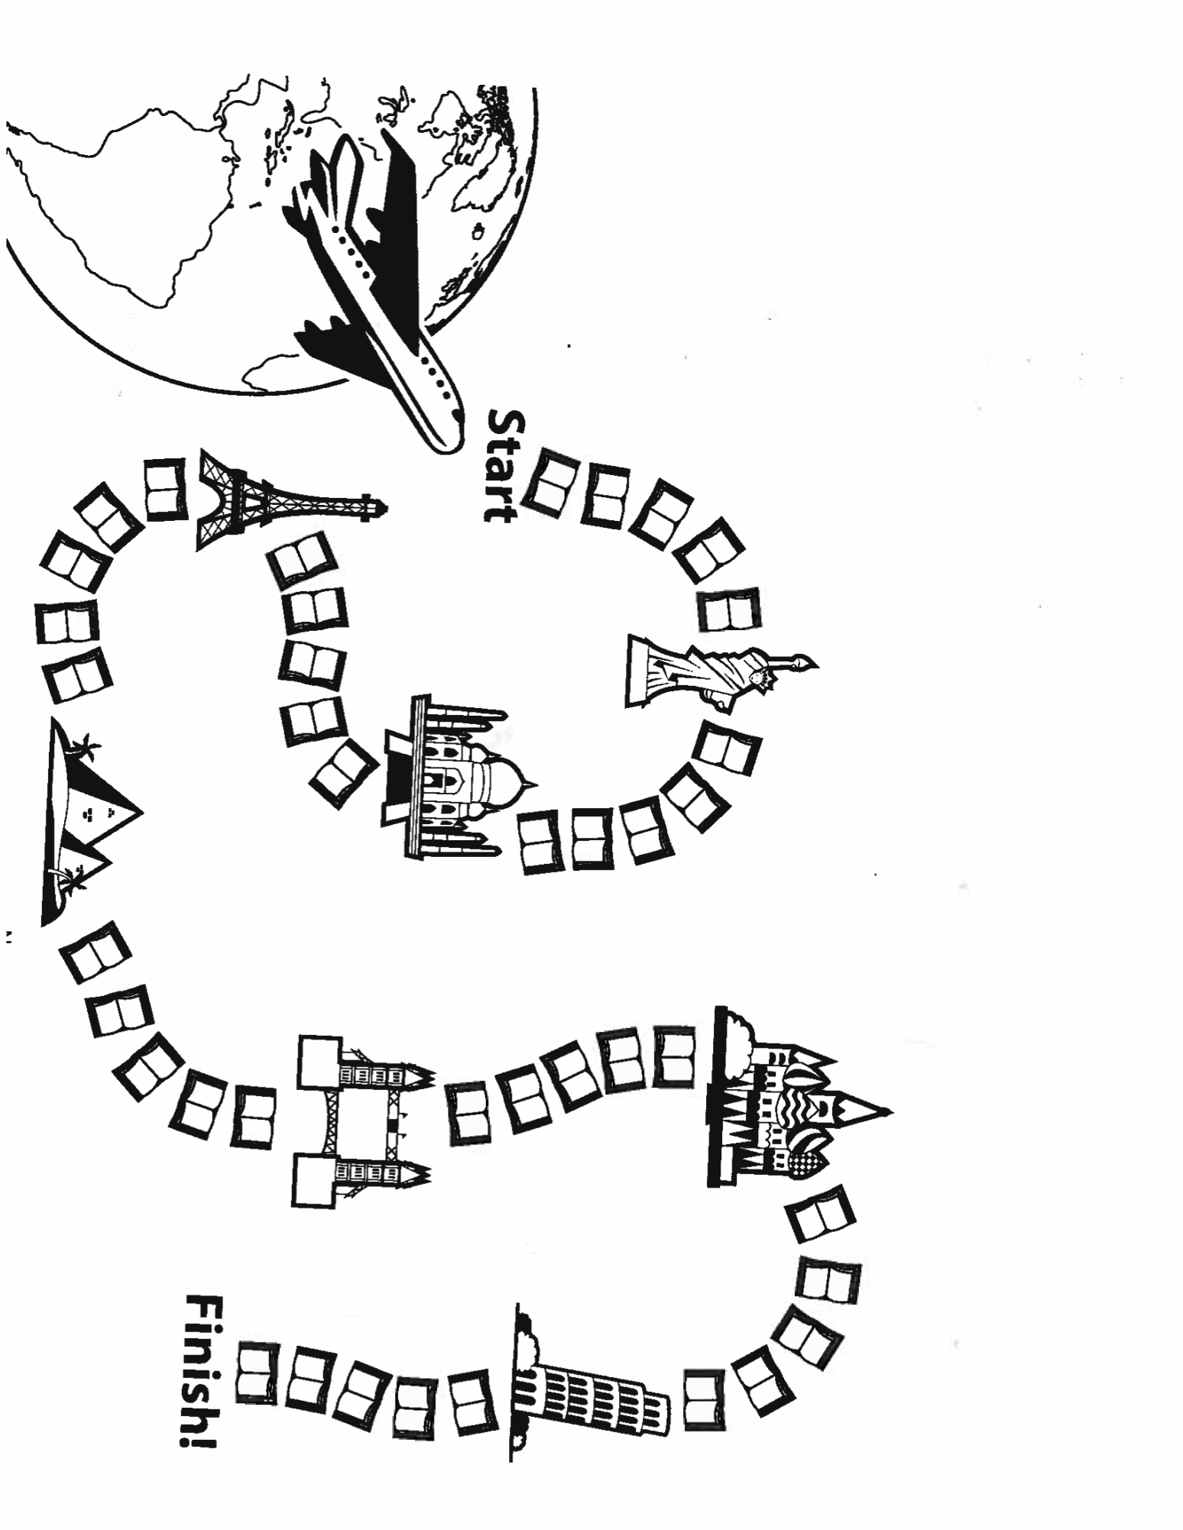
Color one book for every day that you meet your goal

20 minutes or 20 pages a day
30 minutes or 30 pages a day
40 minutes or 40 pages a day
____ minutes or ____ pages a day

TIMOTHY HOUSE
SUMMER READING LOG

NAME

BOOKS I’VE READ: Name
Book Title Author

Book Title Author

