TIMOTHY HOUSE - DWIGHT SCHOOL

SUMMER READING 2017
Fourth Grade into Fifth Grade

Reading over the summer reinforces reading skills and encourages children to become life-long learners.
Please assist your child with his/her summer reading and note the Summer Reading Activities listed below.
Dear Students:
We have attached a list of suggestions of books to read over the summer. Please read at least THREE books from the list below. However, if you find another book you really love, go ahead and read it! We hope you devour books this summer, so feel free to choose one that is not on the list. It is a good idea to go to the library or bookstores to decide which books are a good match for you.

We have listed the books, their authors, and a brief summary to help you make your choices. Again, feel free to read as many as you would like! We have included a reading log so you can keep track of all the great reading you do this summer.

All students are to read Out of My Mind, by Sharon Draper. This is a grade level requirement for 5th grade.

For each of the 3 books you read, complete one of the following activities. Please choose a different activity for each book:

- You’re a new fifth grade teacher. Write a review of the book explaining to parents why, or why not, this is a great book for fifth graders to read.

- You’re a reporter. Write a front-page news story or a report live from the scene of one of main character’s adventures.

- You’re a children’s book reviewer. Write a review discussing one lesson that you think that this book teaches and explain why this lesson is important.

- You are an artist. Illustrate a picture of your favorite scene from the book. Prepare a caption that could hang in the museum next to your illustration explaining your drawing.

- You are a literary agent. Write a letter to the publishing company designed to persuade them to publish the book.

While we only require you to read 3 books, we would encourage you to read a variety of books in addition to the list we have provided for you.

Have a wonderful summer and we look forward to seeing you in the fall!
FICTION:

Out of My Mind by Sharon M. Draper ~ Mandatory Read

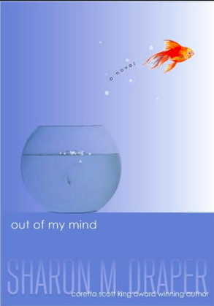
Eleven-year-old Melody has a photographic memory. Her head is like a video camera that is always recording. Always. And there's no delete button. She's the smartest kid in her whole school, but no one knows it. Most people — her teachers and doctors included — don't think she's capable of learning, and until recently her school days consisted of listening to the same preschool-level alphabet lessons again and again and again. If only she could speak up, if only she could tell people what she thinks and knows...but she can't, because Melody can't talk. She can't walk. She can't write.

Amina’s Voice by Hena Khan
.
Amina has never been comfortable in the spotlight. She is happy just hanging out with her best friend, Soojin. Except now that she’s in middle school everything feels different. Soojin is suddenly hanging out with Emily, one of the “cool” girls in the class, and even talking about changing her name to something more “American.” Does Amina need to start changing too? Or hiding who she is to fit in? While Amina grapples with these questions, she is devastated when her local mosque is vandalized.
Booked by Kwame Alexander

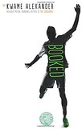
In this follow-up to the Newbery-winning novel THE CROSSOVER, soccer, family, love, and friendship, take center stage as twelve-year-old Nick learns the power of words as he wrestles with problems at home, stands up to a bully, and tries to impress the girl of his dreams. Helping him along are his best friend and sometimes teammate Coby, and The Mac, a rapping librarian who gives Nick inspiring books to read.
This electric and heartfelt novel-in-verse by poet Kwame Alexander bends and breaks as it captures all the thrills and setbacks, action and emotion of a World Cup match!

Family Fletcher takes Rock Island by Dana Alison Levy
The Fletchers are back on Rock Island, home of all their best summer memories. But from their first day on vacation, it’s clear that this year, things have changed. Their favorite lighthouse is all boarded up‘ and the Fletcher boys can’t figure out why or how to save it. Add a dose of Shakespeare, a very tippy kayak, a video camera, (maybe, possibly, or not) a swimming cat, and some new neighbors, and the recipe for a crazy vacation is complete.

Flying Lessons and other stories
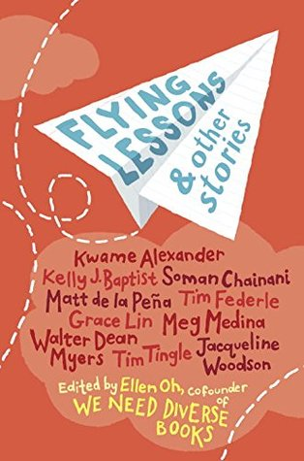
Whether it is basketball dreams, family fiascos, first crushes, or new neighborhoods, this bold anthology—written by the best children’s authors—celebrates the uniqueness and universality in all of us. In a partnership with We Need Diverse Books, industry giants Kwame Alexander, Soman Chainani, Matt de la Peña, Tim Federle, Grace Lin, Meg Medina, Walter Dean Myers, Tim Tingle, and Jacqueline Woodson join newcomer Kelly J. Baptist in a story collection that is as humorous as it is heartfelt. This impressive group of authors has earned among them every major award in children’s publishing and popularity as New York Times bestsellers.

Garvey’s Choice by Nikki Grimes
Garvey’s father has always wanted Garvey to be athletic, but Garvey is interested in astronomy, science fiction, reading—anything but sports. Feeling like a failure, he comforts himself with food. Garvey is kind, funny, smart, a loyal friend, and he is also overweight, teased by bullies, and lonely. When his only friend encourages him to join the school chorus, Garvey’s life changes. The chorus finds a new soloist in Garvey, and through chorus, Garvey finds a way to accept himself, and a way to finally reach his distant father—by speaking the language of music instead of the language of sports.
Harry Miller’s Run by David Almond
Liam just wants to go out running with his mates – it’s not long till the Junior Great North Run, and there’s training to be done. But Mam needs him today, to help old Harry clear out his house. Harry knows a thing or two about running. When he was a lad, he says, he ran all the way from Newcastle to South Shields. “But Harry,” says Mam, “that’s thirteen miles!” Harry grins. “Different times,” he says. This is the story of that day: of sweltering heat, clattering boots, briny sea air and the heavenly taste of ice cream; the day when Harry and his pals ran and ran and ran through the blazing sunlight all the way to the sea.
Henry and the Chalk Dragon by Jennifer Trafton
In the town of Squashbuckle, just about anything can happen, and when Henry Penwhistle draws a mighty Chalk Dragon on his door, the dragon does what Henry least expects--it runs away. Now Henry's art is out in the world for everyone to see, and it's causing trouble for him and his schoolmates Oscar and Jade. If they don't stop it, the entire town could be doomed! To vanquish the threat of a rampaging Chalk Dragon, Sir Henry Penwhistle, Knight of La Muncha Elementary School, is going to have to do more than just catch his art--he's going to have to let his imagination run wild. And THAT takes bravery.

Maybe a Fox by Kathi Appelt
Sylvie and Jules, Jules and Sylvie. Better than just sisters, better than best friends, they'd be identical twins if only they'd been born in the same year. And if only Sylvie wasn't such a fast—faster than fast—runner. But Sylvie is too fast, and when she runs to the river they're not supposed to go anywhere near to throw a wish rock just before the school bus comes on a snowy morning, she runs so fast that no one sees what happens…and no one ever sees her again. Jules is devastated, but she refuses to believe what all the others believe, that—like their mother—her sister is gone forever. At the very same time, in the shadow world, a shadow fox is born—half of the spirit world, half of the animal world. She too is fast—faster than fast—and she senses danger. She's too young to know exactly what she senses, but she knows something is very wrong. And when Jules believes one last wish rock for Sylvie needs to be thrown into the river, the human and shadow worlds collide.
Rain Reign by Ann M. Martin
Rose Howard is obsessed with homonyms. She's thrilled that her own name is a homonym, and she purposely gave her dog Rain a name with two homonyms (Reign, Rein), which, according to Rose's rules of homonyms, is very special. Not everyone understands Rose's obsessions, her rules, and the other things that make her different – not her teachers, not other kids, and not her single father. When a storm hits their rural town, rivers overflow, the roads are flooded, and Rain goes missing. Rose's father shouldn't have let Rain out. Now Rose has to find her dog, even if it means leaving her routines and safe places to search.

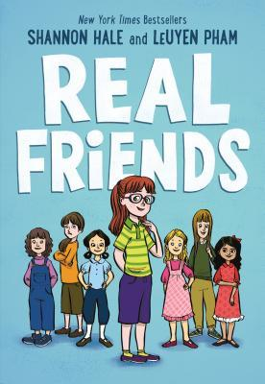
Real Friends by Shannon Hale

Shannon and Adrienne have been best friends ever since they were little. But one day, Adrienne starts hanging out with Jen, the most popular girl in class and the leader of a circle of friends called The Group. Everyone in The Group wants to be Jen's #1, and some girls would do anything to stay on top . . . even if it means bullying others. Now every day is like a roller coaster for Shannon. Will she and Adrienne stay friends? Can she stand up for herself? And is she in The Group—or out?

Sputnik’s Guide to Life on Earth by Frank Cottrell Boyce
Prez keeps his bag packed, positive that his grandfather will pick him up from the Children’s Temporary Accommodation at any moment. But until Granddad gets out of jail, Prez will be spending the summer at the Blythe family’s farm. He has barely arrived when a peculiar individual sporting a kilt and flight goggles appears at the door: Sputnik Mellows. He, too, is welcomed by the Blythes, who are somehow under the impression that he is a dog—handshakes all around! Still more curious, Sputnik can read Prez’s thoughts, a useful skill when dealing with a voluntary mute like Prez. How is all this possible? Sputnik is an alien, and quite a charming one at that, and he needs Prez’s help saving Earth from destruction. If, by the end of summer, the pair of them can come up with 10 things worth seeing—for an interplanetary guidebook—the planet will be saved.

The War that Saved my Life by Kimberly Brubaker Bradley
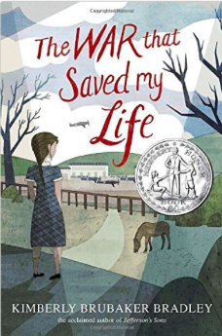
Nine-year-old Ada has never left her one-room apartment. Her mother is too humiliated by Ada’s twisted foot to let her outside. So when her little brother Jamie is shipped out of London to escape the war, Ada doesn’t waste a minute—she sneaks out to join him.
So begins a new adventure of Ada, and for Susan Smith, the woman who is forced to take the two kids in. As Ada teaches herself to ride a pony, learns to read, and watches for German spies, she begins to trust Susan—and Susan begins to love Ada and Jamie. But in the end, will their bond be enough to hold them together through wartime? Or will Ada and her brother fall back into the cruel hands of their mother?

The Wild Robot by Peter Brown
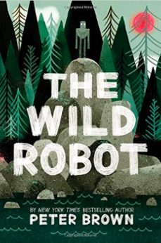
When robot Roz opens her eyes for the first time, she discovers that she is alone on a remote, wild island. She has no idea how she got there or what her purpose is--but she knows she needs to survive. After battling a fierce storm and escaping a vicious bear attack, she realizes that her only hope for survival is to adapt to her surroundings and learn from the island's unwelcoming animal inhabitants. As Roz slowly befriends the animals, the island starts to feel like home--until, one day, the robot's mysterious past comes back to haunt her.
Wolf Hollow by Lauren Wolk
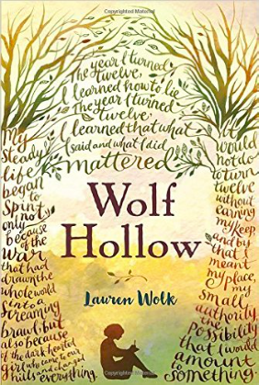
Growing up in the shadows cast by two world wars, Annabelle has lived a mostly quiet, steady life in her small Pennsylvania town. Until the day new student Betty Glengarry walks into her class. Betty quickly reveals herself to be cruel and manipulative, and while her bullying seems isolated at first, things quickly escalate, and reclusive World War I veteran Toby becomes a target of her attacks. While others have always seen Toby’s strangeness, Annabelle knows only kindness. She will soon need to find the courage to stand as a lone voice of justice as tensions mount.

GRAPHIC NOVELS:
Compass South by Hope Larson
It’s 1860 in New York City. When 12-year-old twins Alexander and Cleopatra’s father disappears, they join the Black Hook Gang and are caught by the police pulling off a heist. Neither Alexander nor Cleo realizes the real danger they are in — they are being followed by pirates who think they hold the key to treasure. How they outwit the pirates and find each other makes for a fast-paced, breathtaking adventure.
Feathers by Jorge Corona 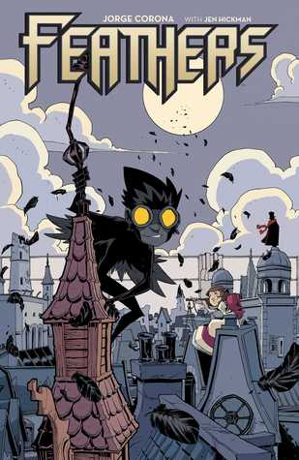
Born covered in black feathers, abandoned as a baby in the slums of the Maze, Poe has lived his entire eleven-year-old life hidden away under the protection of his adoptive father, Gabriel. He spends his days secretly helping the Mice, bands of orphans who roam the slums, but there is a whisper of an altogether more sinister figure in the shadows, making street children disappear. When Bianca, an over-protected girl from the wealthy City beyond the Wall, escapes into the Maze in search of adventure, their worlds collide. As danger looms on all sides, a friendship grows between the city girl and the boy covered in feathers...a friendship that may just be enough to bring Bianca home, and lead Poe to his destiny.

Lowriders in Space by Cathy Camper
Lupe Impala, El Chavo Flapjack, and Elirio Malaria love working with cars. You name it, they can fix it. But the team's favorite cars of all are lowriders—cars that hip and hop, dip and drop, go low and slow, bajito y suavecito. The stars align when a contest for the best car around offers a prize of a trunkful of cash—just what the team needs to open their own shop! ¡Ay chihuahua! What will it take to transform a junker into the best car in the universe?

ADDITIONAL RESOURCES:

Books can be purchased at:
- Bank Street Book Store - 2780 Broadway (between 107th and 108th Street)
- Book Culture on Columbus - 450 Columbus Avenue (between 81st and 82nd Street)
- Barnes & Noble Bookstore - Most Locations
- Amazon

Books can be borrowed from the New York Public Library (www.nypl.org)

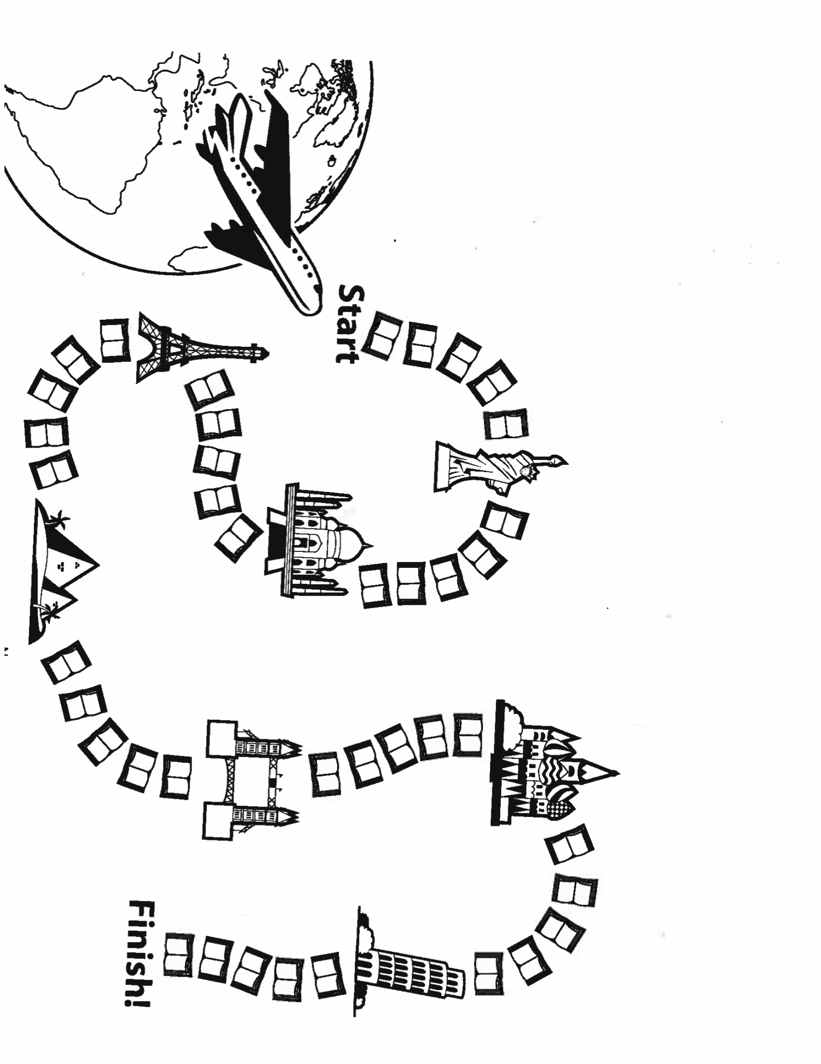
TIMOTHY HOUSE
SUMMER READING LOG
Color one book for every day that you meet your goal

20 minutes or 20 pages a day
30 minutes or 30 pages a day
40 minutes or 40 pages a day
____ minutes or ____ pages a day

NAME

BOOKS I’VE READ: Name
Book Title Author

Book Title Author

Author

