Timothy House
The Dwight School
Summer Reading 2017

Second Grade into Third Grade

Reading over the summer reinforces reading skills and encourages children to become life-long learners.

Please assist your children in their summer reading and note the Summer Reading Activities listed below.

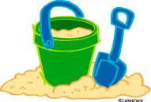

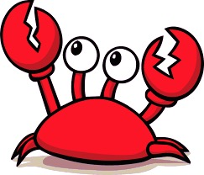

Dear Students,
We hope you have a fabulous summer! While you are on summer break, please read FOUR or more books from the list below. After you have read a book, complete ONE of the projects. You should also log your books into the attached reading log. You will be reading at least four books, but you only have to do a project on ONE book. You need to log all books you read into the reading log.

All projects and reading logs are due on the first day of third grade, September 7th. We look forward to seeing your projects and hearing all about your books and summer adventures in September!

Your Third Grade Teachers
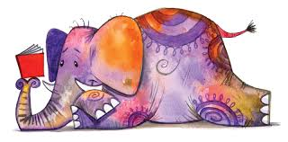

SUMMER READING PROJECTS:
*Choose ONE of the projects from the list below.

- Use your envisioning skills to draw a picture of the main character in your book. Then, choose 4 character traits (e.g. caring, responsible, respectful, etc.) that describe the main character. Underneath or around the drawing, write each trait and explain why you chose it to describe the character.

- Choose a scene from the book that shows a lesson that the book teaches you. Illustrate a picture of this scene and write a caption underneath your illustration that explains the lesson and what’s happening in the scene.
- Write a front-page news story as if you were reporting live from the scene of a problem your main character faces.
- Write a review of the book and explain why this book is or is not a great read for third graders. Make sure to include a summary of the plot, information about the main characters, and an explanation of why others should or should not read it.
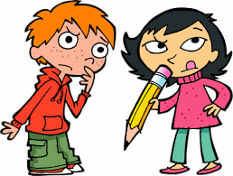

SUMMER READING LIST:
*Choose AT LEAST 4 books from the list below.

PLEASE NOTE:
When choosing books to read over the summer, use your “just right book” skills and be open-minded in your reading choices.

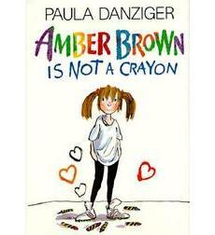
Amber Brown is Not a Crayon by Paula Danziger, J.Galbraith

Amber Brown and Justin Daniels are best friends. They sit next to each other in school, help each other with fractions and spelling, and always stick up for one another. But when Justin finds out that he is moving away, everything begins to change.

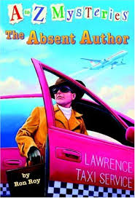
A to Z Mysteries by Ron Roy

Follow the clues to solve the mystery! These books follow the adventures of three junior detectives, Donald David "Dink" Duncan, Joshua "Josh" Pinto, and Ruth Rose Hathaway as they uncover the deepest, darkest secrets of their town.

Clementine by Sara Pennypacker

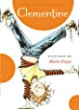
Clementine, a not-so-common third grader, knows her way around the principal's office as well as she does the art-supply closet. Clementine has her own view of the world around her when seen from her eyes. She's constantly being told that she needs to pay attention, but to her mind she is paying attention and making astute observations. Clementine goes to great lengths to be friends with fourth-grade neighbor, Margaret, but more times than not, both girls end up in trouble. (Part of a series)

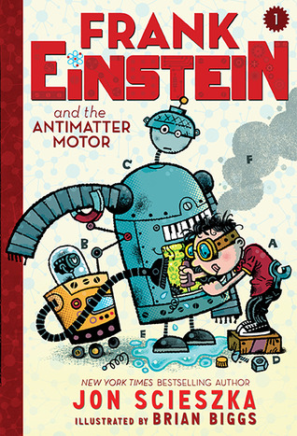
Frank Einstein and the Antimatter Motor by Jon Scieszka

Frank Einstein loves figuring out how the world works by creating household contraptions that are part science, part imagination, and definitely unusual. After an uneventful experiment in his garage-lab, a lightning storm and flash of electricity bring Frank’s inventions—the robots Klink and Klank—to life! Not exactly the ideal lab partners, the wisecracking Klink and the overly expressive Klank nonetheless help Frank attempt to perfect his Antimatter Motor . . . until Frank’s archnemesis, T. Edison, steals Klink and Klank for his evil doomsday plan! (Part of a series)

Harriet the Invincible by Ursula Vernon

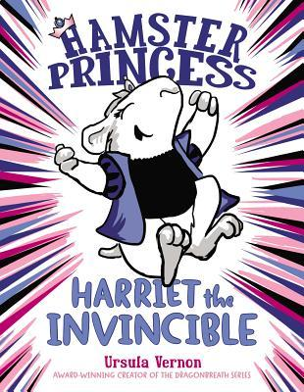
Harriet Hamsterbone is not your typical princess. She may be quite stunning in the rodent realm (you'll have to trust her on this one), but she is not so great at trailing around the palace looking ethereal or sighing a lot. She finds the royal life rather . . . dull. One day, though, Harriet's parents tell her of the curse that a rat placed on her at birth, dooming her to prick her finger on a hamster wheel when she's twelve and fall into a deep sleep. For Harriet, this
is most wonderful news: It means she's invincible until she's twelve! (Part of a series)

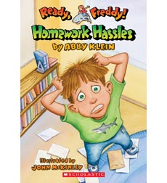
Homework Hassles by Abby Klein

Freddy Thresher has a problem — a really, really, big problem. His teacher wants the class to do reports on nocturnal animals, and everybody but Freddy has a really cool animal to study. How will Freddy find one? When his best friend, Robbie, says the two boys should have a sleepover and sneak outside at night, Freddy makes a huge mistake and ends up getting his late-night wish in a very unexpected way!

Horrible Harry Moves Up to Third Grade by Suzy Kline
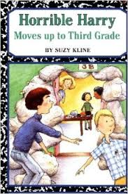
Third grade brings lots of surprises, but one thing hasn't changed: Harry and Sidney are still sworn enemies. And their relationship only gets worse when Sidney accidentally kills Harry's pet spider. But while on a class trip to a scary old prison and a creepy copper mine, Harry comes up with a horribly funny way to get revenge.

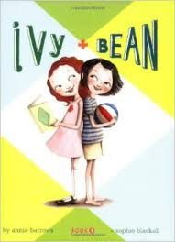
Ivy and Bean by Annie Barrows

The moment they saw each other, Bean and Ivy knew they wouldn't be friends. But when Bean plays a joke on her sister, Nancy, and has to hide quick Ivy comes to the rescue, with her wand, some face paint, and a bucket of worms. Will they end up in trouble? Maybe. Will they have fun? Of course! Sometimes the best of friends are people never meant to like each other. (Part of a series)

Magic Finger by Roald Dahl
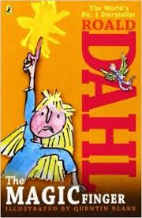
The Gregg family loves hunting, but their eight-year-old neighbor can't stand it. After countless pleas for them to stop are ignored, she has no other choice — she has to put her magic finger on them. Now the Greggs are a family of birds, and like it or not, they're going to find out how it feels to be on the other end of the gun.

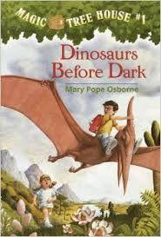
Magic Tree House Series by Mary Pope Osborne

Jack and his little sister Annie are just two regular kids from Frog Creek, Pennsylvania. Then they discover a mysterious tree house packed with all sorts of books...and their lives are never the same! Soon they are traveling through time and space in the magic tree house and having amazing adventures. Whether it's watching baby dinosaurs hatch, finding a secret passage in a castle, helping a ghost queen in an Egyptian pyramid, or finding pirate treasure, readers won't want to miss a single story!

Marvin Redpost Series by Louis Sachar
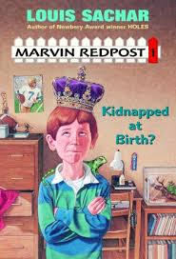
The Newbery medal-winning author of Holes, Louis Sachar, brings his outstanding humor to this series about a boy named Marvin Redpost who encounters hilarious problems with school, family, and friends. This Master of Mayhem will leave you in stitches!

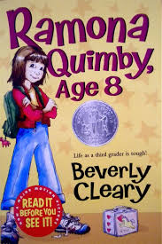
Ramona Quimby, Age 8 by Beverly Cleary

With Mr. Quimby going to college and Mrs. Quimby going to work, it's a good thing Ramona is big enough to ride the bus to her new school all by herself. Soon Ramona is living up to her reputation, accidentally squashing a raw egg into her hair at the cafeteria and throwing up in her classroom. Will life ever get any easier? (Part of a series)

Roberto Clemente by Wil Mara
In this title, young readers learn about Roberto Clemente, baseball Hall of Famer and one of Puerto Rico's national heroes. Learn how he joined the Pittsburgh Pirates in 1955 and won the Golden Glove award twelve seasons in a row. After his death in 1972, Clemente was voted into the Baseball Hall of Fame.

Rosa Parks: Revised Edition by Wil Mara
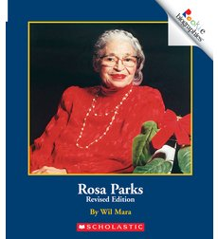
In this revised edition from the "Rookie Biographies" series, young readers will learn about the life of Rosa Parks, a woman who took a stand against injustice and helped gain equal rights for African Americans.

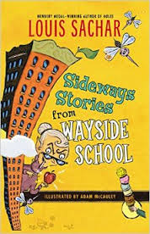
Sideways Stories from Wayside School by Louis Sachar

There was a terrible mistake - Wayside School was built with one classroom on top of another, thirty stories high (The builder said he was sorry.) Maybe that's why all kinds of funny things happened at Wayside-especially on the thirteenth floor. (Part of a series)

Superfudge by Judy Blume

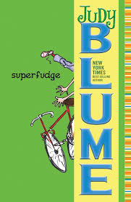
Twelve-year-old Peter Hatcher's brother, Fudge, has driven him up the wall since Day One! Now that he's older, Fudge is an even bigger pain; he eats worm brownies, insists on getting a myna bird for a pet, and is constantly singing words he knows how to spell. What could be worse? Well, Peter soon finds out that his mom is pregnant and the family is going to move to Princeton, New Jersey. Now Peter has to leave his best friend, Jimmy, and his archenemy, Sheila Tubman, behind. Not only that, he has to start the sixth grade in a new school — plus, it's the same school that Fudge is going to attend! What can he do now?

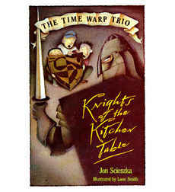
Time Warp Trio: Knghts of the Kitchen Table by Jon Scieszka

Joe's been caught up in a book before, but this is ridiculous! Joe's Book, a gift from his magician uncle, doesn't just tell stories, it zaps Joe and his friends Sam and Fred right into the middle of them. And when these thoroughly modern kids meet King Arthur and become Knights of the Round Table, the result can only be thoroughly amusing mayhem.

Wingman on Ice by Matt Christopher
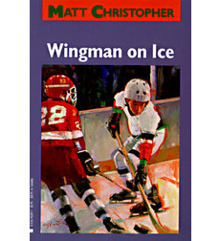
When fifth-grader Tod receives a new hockey stick for Christmas, he decides that he must earn the right to use it by playing better. However, as the season draws to a close, he wonders if he will have to wait until next year to use it.

What Is Ellis Island by Patricia Brennan Demuth
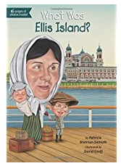
From 1892 to 1954, Ellis Island was the gateway to a new life in the United States for millions of immigrants. In later years, the island was deserted, the buildings decaying. Ellis Island was not restored until the 1980s, when Americans from all over the country donated more than $150 million. It opened to the public once again in 1990 as a museum. Learn more about America's history, and perhaps even your own, through the story of one of the most popular landmarks in the country.

What Is the Statue of Liberty by Joan Holub
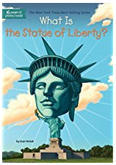
In 1876, France decided to give the United States a very big and very special present--the Statue of Liberty. The gift was to commemorate the 100th birthday of the United States, and just packing it was no small feat--350 pieces in 214 crates shipped across the ocean. The story of how the 111-foot-tall lady took her place in the New York Harbor will fascinate young readers.

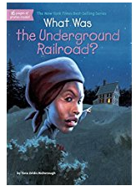
What Was the Underground Railroad by Yona Zeldis McDonough and Lauren Mortimer

No one knows where the term Underground Railroad came from--there were no trains or tracks, only "conductors" who helped escaping slaves to freedom. Including real stories about "passengers" on the "Railroad," this book chronicles slaves' close calls with bounty hunters, exhausting struggles on the road, and what they sacrificed for freedom. With 80 black-and-white illustrations throughout and a sixteen-page black-and-white photo insert, the Underground Railroad comes alive!

What Were the Twin Towers by Jim O’Connor
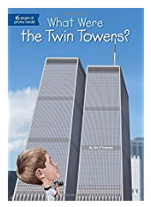
When the Twin Towers were built in 1973, they were billed as an architectural wonder. At 1,368 feet, they clocked in as the tallest buildings in the world and changed the New York City skyline dramatically. Offices and corporations moved into the towers—also known as the World Trade Center—and the buildings were seen as the economic hub of the world. But on September 11, 2001, a terrorist attack toppled the towers and changed our nation forever. Discover the whole story of the Twin Towers—from their ambitious construction to their tragic end.

ADDITIONAL RESOURCES:

- Books can be purchased at:

- Bank Street College Book Store
2780 Broadway (between 107th and 108th Street)

- Book Culture on Columbus
450 Columbus Avenue (between 81st and 82nd Street)

- Barnes & Noble Bookstore

- www.Amazon.com

- Books can be borrowed from the New York Public Library (www.nypl.org)

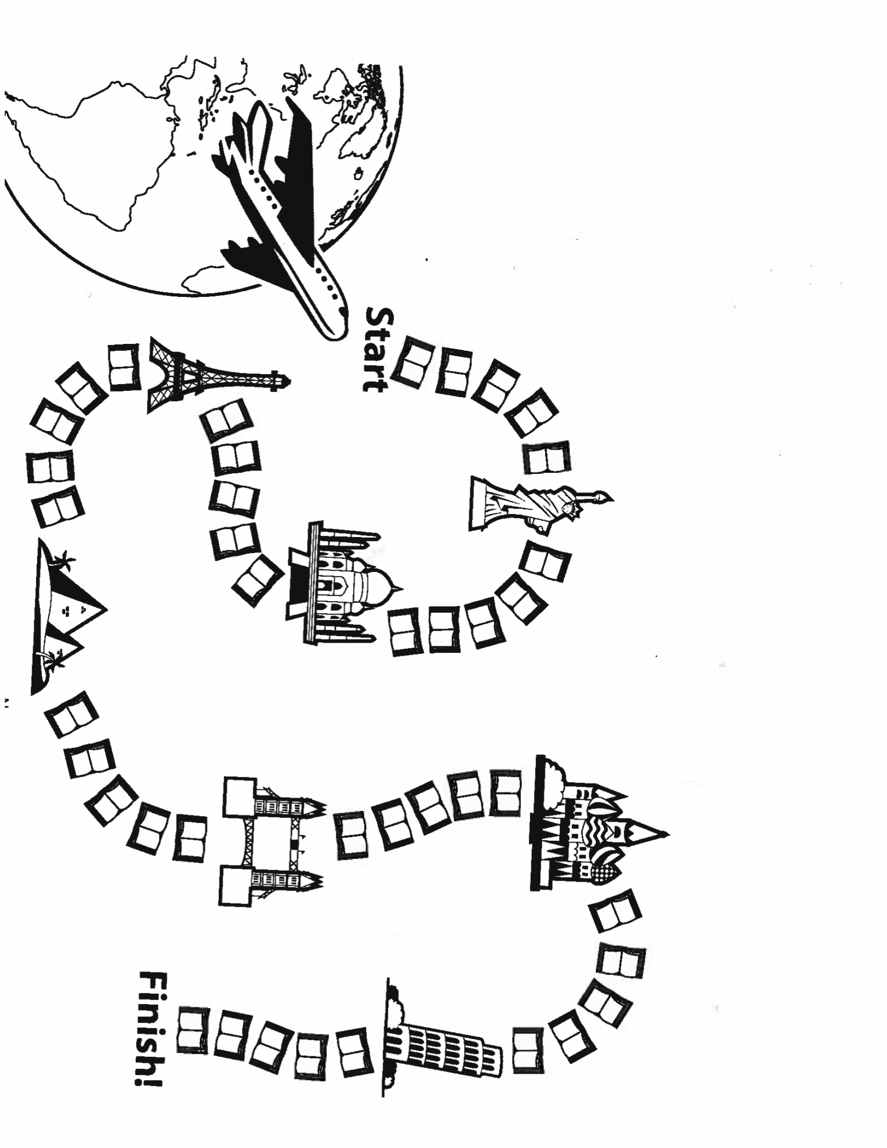
Color one book for every day that you meet your goal

20 minutes or 20 pages a day
30 minutes or 30 pages a day
40 minutes or 40 pages a day
____ minutes or ____ pages a day

TIMOTHY HOUSE
SUMMER READING LOG

NAME

BOOKS I’VE READ: Name
Book Title Author

Book Title Author

