TIMOTHY HOUSE
DWIGHT SCHOOL
SUMMER READING 2017

Kindergarten into First Grade

Reading over the summer reinforces reading skills and encourages children to become life-long learners.

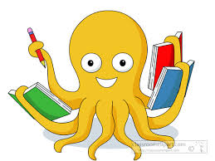

Dear Parents,

Reading books aloud with children stimulates their imagination and expands their understanding of the world. It helps them develop language and listening skills and prepares them to understand the written word.

In order to foster a love of reading in our first graders, it is important that they listen to stories read to them as well as reading independently both new and familiar texts.

In order to maintain the skills they have developed in kindergarten, and to prepare them for first grade, students should be reading as much as possible during the summer—at least 10-20 minutes every day. Attached, you will find a book review sheet. Over the summer, each student should complete at least four book reviews documenting some of the books he or she is reading. These should be submitted to the student’s first grade teachers at the start of the school year.

Attached is our suggested summer reading list. Please note that many of the titles below are part of a series or by well-known authors of children’s books. You are encouraged to explore these additional titles by using the resources listed on the last page of this list.

Recommended reading:

Picture Books:

Ada Twist, Scientist by Andrea Beatty
Airport Book by Lisa Brown
Are We There Yet? By Dan Santat
Extra Yarn by Mac Barnett
Flora and the Flamingo by Molly Idle

How Rocket Learned to Read by Tad Hill

If You Give a Mouse a Cookie by Laura Joffe Numeroff
Journey by Adam Becker

Leave Me Alone! by Vera Brosgol

Little Pea by Amy Krouse Rosenthal
My Rhinoceros by Jon Agee
School’s First Day of School by Adam Rex
This Is Not My Hat by Jon Klassen
Visitor for Bear by Bonny Becker
You Will Be My Friend! By Peter Brown
Elephant and Piggie by Mo Willems (series)

Early Chapter Books:
(most of these are series)
Danny and the Dinosaur by Syd Hoff
Fly Guy by Ted Arnold
Frog and Toad by Arnold Lobel
Go, Otto, Go by David Milgrim
Henry and Mudge by Cynthia Rylant
Little Mouse by Jeff Smith

Teacher favorites:
Chrysanthemum by Kevin Henkes
Click, Clack, Moo by Doreen Cronin
Harold and the Purple Crayon by Crockett Johnson
Horton Hatches the Egg by Dr. Seuss
Miss Nelson is Missing by Harry Allard
Strega Nona by Tomie dePaola
Sylvester and the Magic Pebble by William Steig
Green Eggs and Ham by Dr. Seuss

Books by Eric Carle, Maurice Sendak, and Bill Martin

Informational/Nonfiction Book Suggestions:

Among a Thousand Fireflies by Helen Frost
Animals by the Numbers by Steve Jenkins
Beetle Book by Steve Jenkins
Blizzard by John Rocco
Circle by Jeannie Baker
Desert Giant by Barbara Bash
Eating the Alphabet by Lois Ehlert
Moon Book by Gail Gibbons
Neighborhood Sharks by Katherine Roy
Ocean Animals from Head to Tail by Stacey Roderick
Otters Love to Play by Jonathan London
A Rock Is Lively by Dianna Hutts Aston
The Secret Subway by Shana Corey
When Green Becomes Tomatoes by Julie Fogliano
You Never Heard of Casey Stengel? by Jonah Winter

Feel free to explore additional books that are not on the list provided.

ADDITIONAL RESOURCES:

- Books can be purchased at:

- Bank Street College Book Store
2780 Broadway (between 107th and 108th Street)

- Book Culture on Columbus
450 Columbus Avenue (between 81st and 82nd Street)

- Barnes & Noble Bookstore
Most Locations

- Books can be borrowed from the New York Public Library (www.nypl.org)

Summer Book Review
After reading or listening to a book, complete the review below.

Book Title_________________________________________________________

Author____________________________________________________________

Illustrator__________________________________________________________
What was your favorite part of the book? You may write or draw.

One Star  (Not that interesting) | Two Stars  (Somewhat Interesting) | Three Stars  (Very Interesting)
I give this book (circle one):

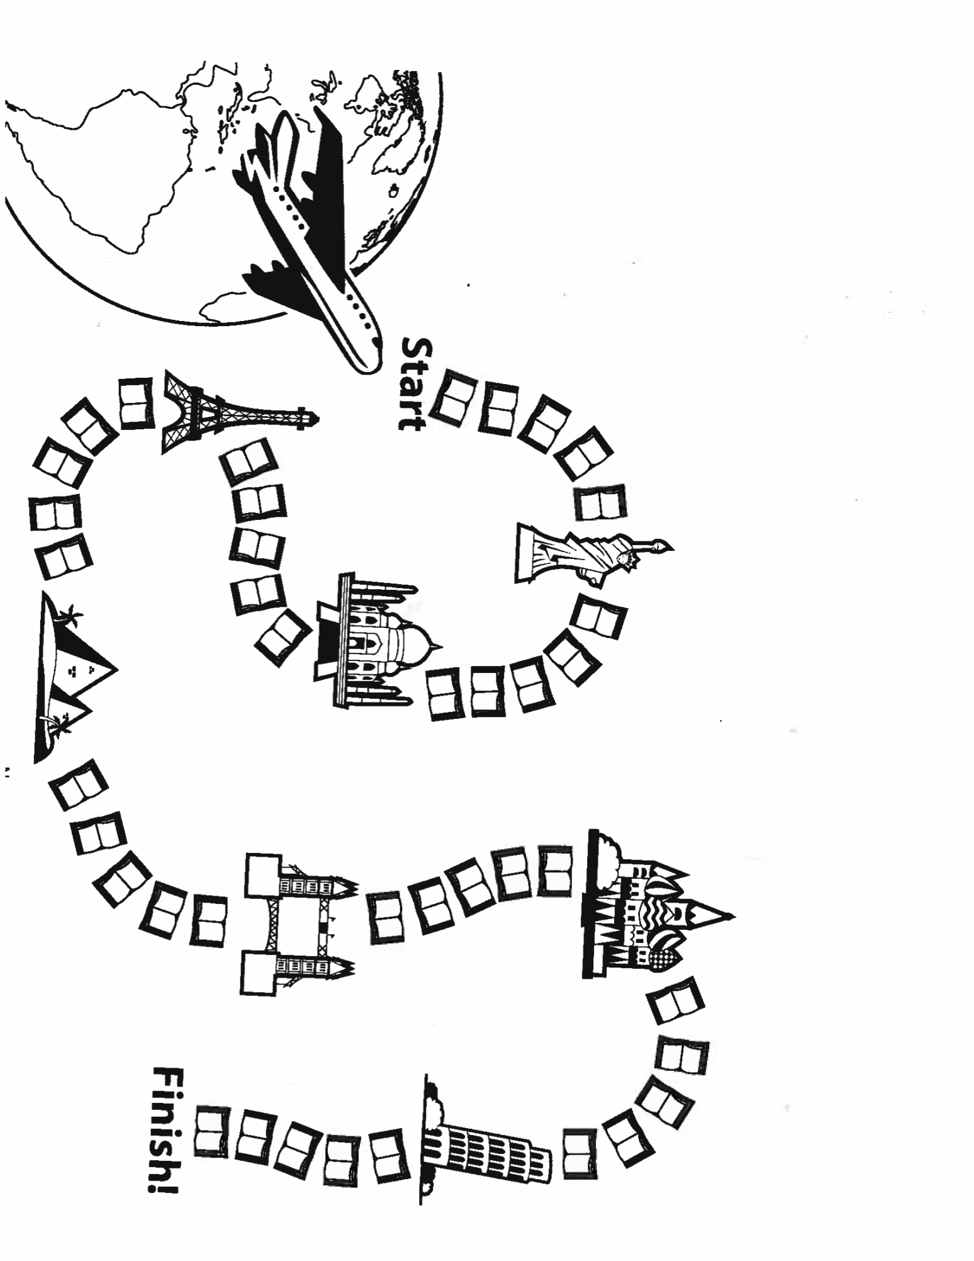
Color one book for every day that you meet your goal

10 minutes_____
15 minutes_____
20 minutes_____
____minutes

TIMOTHY HOUSE
SUMMER READING LOG

NAME

BOOKS I’VE READ: Name
Book Title Author

Book Title Author

